Dear Parents

Year 2 – Australia Day
On Thursday 26th January the Year 2 classes celebrated Australia Day as part of their Geography and English learning. The day began with a costume parade, which included all the children explaining their outfits. We then started our food workshops (prior to Thursday the children had baked Anzac biscuits) during which we made fairy bread, vegemite sandwiches and pavlova. Our morning activities also included a Zoom call with Ms Gina ​Cathro, an ex-Primary School Teacher near Melbourne Australia, and a visit with Kaida - the bearded dragon!

After lunch we made some Aboriginal themed art of boomerangs, Australian animals and played some Australian themed party games. When we were able to taste all the delectable Australian food, can you guess what our overwhelming favourite was? Anzac Biscuits! Overall, it was an exhilarating, fun-filled day full of enthusiastic learning. Here's what the children thought:

"Seeing Mrs Woolgar's Australian friend on the video call and asking questions was my favourite." – Chase

"I liked baking and eating the Australian food because it was tasty!" – Reya

"I enjoyed learning the Australian song because I'd never heard it before." – Aaron

"The Australian party games were fun." – Hayden

"Painting a boomerang was my favourite because I like painting." - Faith

"I liked the costume parade because I got to see everyone's costumes." – Alex

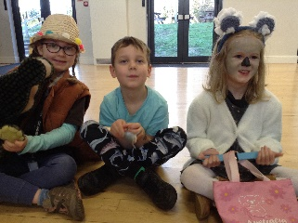
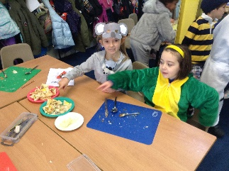
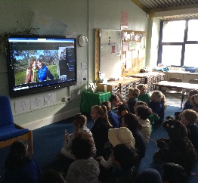
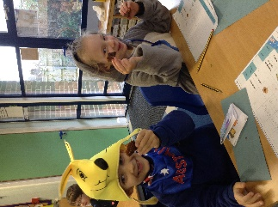
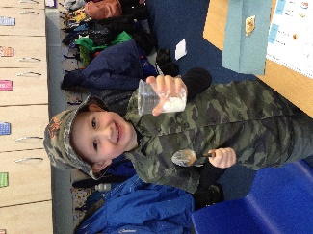

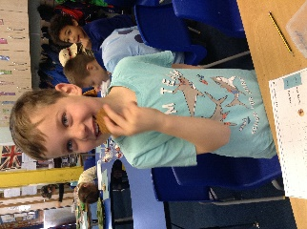
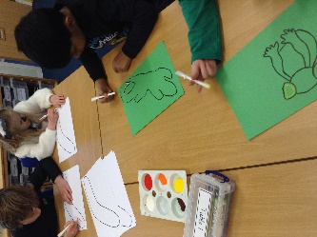
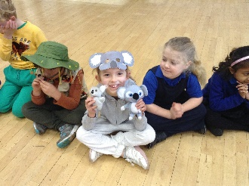
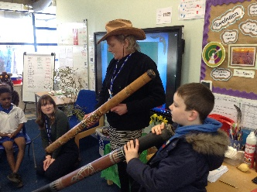
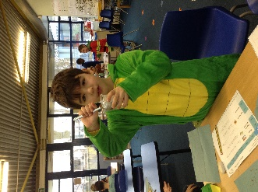

We currently have vacancies for a Class Teacher and an After School Club Assistant. For further details and an application form please see the Vacancies page on our website: https://www.stpetershants.co.uk/vacancies/
If you have pre-school children and like the sound of St Peter’s School then why not contact us to find out about the application process? Telephone 01962 852820 or email admin@st-peters.hants.sch.uk.

Best wishes

Louise Buxton (Miss)
Headteacher

