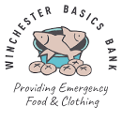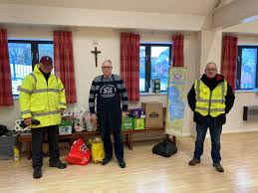
WINCHESTER BASICS BANK
Winchester Basics Bank was established, almost 20 years ago, to provide an emergency food and clothing service for people facing difficulty following an unexpected event in their lives. In recent years the demand for our help has risen exponentially, especially in the current cost-of-living crisis.
We are a Christian charity supported by local churches, schools, caring organisations and individuals, together with local supermarkets and Winchester City Council. Food is donated “By the Community for the Community” directly from local residents via our collection points in local supermarkets or by organisations eg at harvest-time;despite this generous support, demand is now outstripping the donations we receive and we are purchasing additional stocks of food every week thanks to financial donations from generous individuals, businesses and charitable groups.
Our clients are referred to us by over 80 agents including the City Council, Citizens Advice Bureau, Housing Associations, local caring charities such as the Trinity Centre and local churches. Clients are able to choose enough food for 5 days at any of our 4 hubs, and can visit us up to eight times in a year. We also provide food for lunches during holiday periods to many families.
Please help by donating food, money or your time and energy.
Up-to-date information and details about donating and volunteering are posted on our website www.winchesterbasicsbank.co.uk
on our Facebook page https://www.facebook.com/pages/Winchester-Basics-Bank/1377373542487373
and on Instagram

Parish Contact: Mary Alveyn, Trustee

